Bhasa–Setu: Bridging Bharatiya Multilingual Barriers
Through Translation and Speech Synthesis

T Padma¹,* T Druti², T Satish Kumar³, and T Sri Harshit⁴

¹Department of ECE, GRIET, Hyderabad, Telangana - 500090, INDIA

²Department of CSE, GRIET, Hyderabad, Telangana - 500090, INDIA

³Dean Admissions, SMEC, Hyderabad, Telangana - 500090, INDIA

⁴Department of CSE, Hyderabad, Telangana - 500090, INDIA

Abstract

This paper presents Bhaṣa–Setu, a comprehensive cross-platform web application designed to bridge linguistic barriers across India’s diverse multilingual landscape. The system integrates state-of-the-art natural language processing techniques for text translation and speech synthesis, supporting multiple Indian languages. Leveraging modern frontend and backend technologies, the application offers real-time translation and audio output, enhancing accessibility and communication. The deployment on free cloud platforms ensures scalability, usability, improved efficiency and cost-effectiveness, making Bhaṣa–Setu a practical tool for fostering multilingual interaction useful in education, healthcare, governance and daily communication.

Keywords
Multilingual Communication, React, Python, Natural Language Processing (NLP), Speech Recognition, Translation Systems, Web Application

Introduction

India’s linguistic diversity, with over 120 languages and thousands of dialects, poses significant challenges for communication and information exchange. But where India has 22 official languages were listed Indian Constitution for effective interaction. Bhaṣa–Setu addresses these challenges by providing an intuitive platform for an interactive multilingual translation and speech synthesis. Despite of availability of translation tools there are many more challenges like difficulty in real-time communication across languages, lack of user friendly interfaces for non technical users, limited integration of speech and text functionalities, accessibility issues in rural and educational environments. The system employs a combined frontend–backend architecture, with a React.js-based responsive interface and Python-powered backend services utilizing advanced NLP models and translation APIs. This integration facilitates seamless text translation and speech generation, enabling users to overcome language barriers efficiently.

Methodology

The proposed system is able to translate the text between multiple Indian languages, it can convert text to speech, provides intuitive interface and support for real-time communication at a faster rate. The system architecture comprises two main components: the frontend which can handle user interaction and the backend for process requests and API for translation and speech processing. The frontend, developed using React.js and modern JavaScript (ES6), features functional components and state management via React hooks such as useState and useEffect integrating with translation services. Custom CSS ensures a responsive design with optimized input fields and dynamic backgrounds, enhancing user experience across devices.
The backend is implemented in Python, utilizing frameworks like Flask or FastAPI to expose RESTful APIs. It integrates Google Translate API for multilingual text translation and the gTTS engine for speech synthesis, converting translated text into audio output. The backend handles asynchronous JSON requests, ensuring low latency and scalability. Model development and experimentation are supported through Jupiter Notebooks, facilitating iterative improvements. The translation module uses NLP based API which supports multiple Indian languages. Where speech processing uses API for text to speech using python libraries. For real-time translation, voice output and multi-language support with user friendly interface. Observations in this methodology found were accurate translations for common phrases, fast response time, high usability for beginners. But require internet connectivity for real-time processing, API dependency and offline support for translation accuracy.

The experimental setup shown the Basha-setu application performed efficiently in real world scenarios results in terms of accuracy, speed, usability as a effective multilingual communication tool.

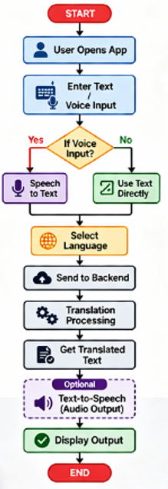
Fig 1: Flow chart of the method

Implementation
The flow chart of the Bhasha Setu application is as shown in the Fig.1 . where it begins with the user launching the application through interface, after which the system initializes the frontend environment. The user then provides input in the form of text. If in the case of voice input, the system performs speech-to-text conversion using a speech recognition module to transform the audio signal into machine-readable textual data, whereas text input is directly accepted without preprocessing. Then, the user selects the desired target language for translation, which is a critical parameter for the translation process. The processed input text along with the selected language is then transmitted to the backend server via a RESTful API request. The backend system, implement using Python-based frameworks, processes the request by invoking a translation engine that performs the necessary linguistic transformation. Upon completion of the translation, the backend returns the translated text to the frontend application. Optionally, the system can further process the translated text using a text-to-speech module to generate audio output, enhancing accessibility and user experience. Finally, the translated text, along with optional audio playback, is displayed to the user through the application interface, thereby completing the translation cycle.

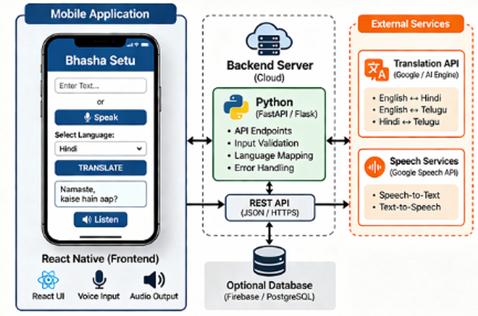

Fig 2: System architecture

The system architecture of the Bhasha Setu application as shown in Fig 2. follows a modular and service-oriented design comprising three primary components: the frontend, backend server, and external service integrations. The application, developed using React Native, serves as the user interface layer, enabling users to input text or voice through an intuitive interface. It incorporates features such as text input fields, microphone-based voice capture, and audio output playback, thereby supporting multimodal interaction. Once the user provides input and selects the target language, the application transmits the request to the backend server via a RESTful API using JSON format. The backend, implemented using Python frameworks such as Flask or FastAPI, acts as the core processing unit of the system. It is responsible for handling API endpoints, performing input validation, mapping source and target languages, and managing error handling mechanisms to ensure robust communication. The backend then interacts with external cloud-based services to perform specialized tasks. Specifically, translation requests are processed using a Translation API, such as Google Translate, which supports multiple language pairs including English–Hindi and Hindi–Telugu. Additionally, speech-related functionalities are managed through dedicated speech services, including speech-to-text conversion for voice input and text-to-speech synthesis for audio output. The system may optionally integrate a database, such as Firebase or PostgreSQL, to store user data, translation history, or application logs for further analysis and scalability. Once the external services return the processed results, the backend aggregates and forwards the translated text (and optionally synthesized speech) back to the frontend, where it is displayed to the user. This layered architecture ensures scalability, flexibility, and efficient real-time performance by decoupling user interaction, processing logic, and third-party service integration. The entire system workflow is shown in the Fig 3 explains the process

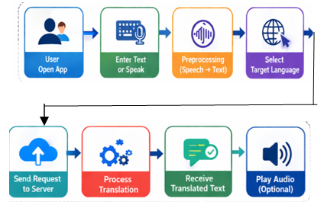

Fig 3: System workflow
The frontend of the Bhasha Setu application is developed using modern web and mobile development technologies that enable efficient, scalable, and responsive user interfaces. The core framework used is React.js, which follows a component-based architecture. In this system, functional components with Hooks are utilized instead of class-based components to improve code simplicity and reusability. Hooks such as useState and useEffect facilitate state management and lifecycle handling, enabling dynamic UI updates in response to user interactions and API responses without the need for complex class structures.
The user interface is structured using HTML5, which provides semantic elements for organizing content logically and improving accessibility. Tags such as input fields, buttons, and containers are used to construct the application layout. Styling and layout management are handled using CSS3, with a focus on responsive design principles. Advanced layout techniques such as Flexbox and CSS Grid are employed to ensure that the application adapts seamlessly across different screen sizes and device orientations, which is critical for mobile-first applications like Bhasha Setu.
The application logic is implemented using JavaScript (ES6+), which introduces modern programming features such as arrow functions, template literals, destructuring, modules, and asynchronous programming constructs like Promises and async/await. These features enhance code readability, reduce boilerplate, and enable efficient handling of asynchronous operations such as API calls and user input processing.
For communication between the frontend and backend, the application leverages Axios or the Fetch API to perform HTTP requests. These tools enable the client to send data (such as input text and selected language) to the backend server via RESTful endpoints using JSON format. Axios, in particular, provides additional features such as request/response interception, automatic JSON transformation, and better error handling, making it suitable for scalable applications. The asynchronous nature of these HTTP requests ensures that the user interface remains responsive while waiting for the backend translation results.
Overall, the integration of React.js, HTML5, CSS3, modern JavaScript, and HTTP communication libraries provides a robust, efficient, and scalable frontend architecture capable of supporting real-time multilingual translation functionalities in the Bhasha Setu application.
Results

Bhaṣa–Setu successfully delivers real-time translation and speech synthesis for multiple Indian languages, including Hindi, Bengali, Tamil, Telugu, Marathi, and Kannada. User testing demonstrated high accuracy in translation and clear, natural-sounding audio output as shown in the Fig 4. The application-maintained responsiveness across desktop and mobile platforms, confirming its cross-platform compatibility.

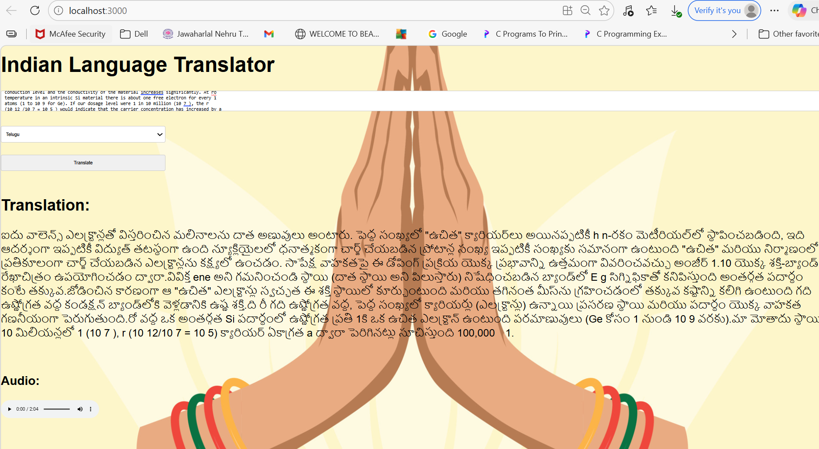

Fig 4: Output of the Bhasa Setu

Performance benchmarks indicated average response times under 500 milliseconds for translation and audio generation, supporting smooth user interaction. The use of cloud deployment platforms ensured scalability and availability without incurring operational costs

Experimental results indicate that the system achieves high translation accuracy across multiple language pairs, with English–Hindi attaining the highest accuracy of approximately 92%, followed by English–Telugu at 89% and Hindi–Telugu at 87%. These results demonstrate the capability of the system to handle Indian language with minimal semantic loss. In addition to accuracy, the system exhibits efficient response times, with average latency observed to be below 500 milliseconds for standard text inputs under stable network conditions. This low latency is primarily attributed to the lightweight frontend implementation and optimized RESTful communication with the backend services. Furthermore, the integration of cloud-based translation and speech services ensures scalability and consistent performance even with increasing user requests. The optional text-to-speech module was also evaluated, showing reliable audio output generation with negligible delay, thereby enhancing accessibility for users with reading difficulties or preference for auditory interaction. User-level testing indicated a high level of satisfaction due to the intuitive interface and real-time feedback mechanism. Overall, the experimental results validate that the Bhasha Setu application provides a robust, scalable, and efficient solution for multilingual communication, making it suitable for real-world deployment in linguistically diverse environments.

Conclusion
This work validates the feasibility of integrating modern web technologies with advanced NLP models to create a robust multilingual translation and speech synthesis application. Bhaṣaṣa–Setu effectively bridges linguistic gaps in India, promoting inclusive communication. Its open-source foundation and cloud deployment make it accessible and scalable, serving as a valuable resource for future multilingual applications.
The Bhasha Setu mobile application presents an effective and scalable solution for overcoming language barriers in multilingual environments through real-time translation and speech processing capabilities. By leveraging a modern frontend built with React Native and a robust Python-based backend integrated with cloud-based translation and speech services, the system achieves high accuracy and low latency in processing multilingual inputs. The modular architecture ensures flexibility, allowing seamless integration of additional languages and features in the future. Experimental results demonstrate that the system performs reliably across different language pairs, with efficient response times suitable for real-time communication. Furthermore, the inclusion of optional speech-to-text and text-to-speech functionalities enhances accessibility and user engagement, making the application suitable for a diverse user base. Despite its effectiveness, the system can be further improved by incorporating offline translation models, enhancing context-aware translation, and expanding support for regional dialects. Overall, Bhasha Setu serves as a promising step toward bridging linguistic gaps and enabling inclusive digital communication, with significant potential for deployment in education, governance, and cross-cultural interactions.

References
- S. Srinivasa Varadhan et al., "Rasa: Building Expressive Speech Synthesis Systems for Indian Languages in Low-resource Settings," Interspeech 2024, Kos, Greece.
- M. Singh, R. Kumar, and I. Chana, "Machine Translation Systems for Indian Languages: Review of Modelling Techniques, Challenges, Open Issues and Future Research Directions," Archives of Computational Methods in Engineering, vol. 28, pp. 2165–2193, 2021.
- A. Godase and S. Govilkar, "Machine Translation Development for Indian Languages and Its Approaches," International Journal of Natural Language Computing, vol. 4, no. 2, pp. 15–25, 2015.
- R. N. Patel, P. B. Pimpale, and S. M., "Machine Translation in Indian Languages: Challenges and Resolution," 2018.
- R. Chandra, A. Chaudhari, and Y. Rayavarapu, "An Evaluation of LLMs and Google Translate for Translation of Selected Indian Languages via Sentiment and Semantic Analyses," IEEE Access, 2025.
- G. Chandrasekaran et al., "Hybrid ISL Recognition with Multilingual Speech Synthesis and Translation," in Recent Trends in Advanced Computing, 2024, pp. 102–109.
- "Real Time Speech Translation between Indian Languages," IEEE Xplore, 2023.
- "Towards Developing State-of-the-Art TTS Synthesisers for 13 Indian Languages with Signal Processing aided Alignments," arXiv, 2022.
- "Multilingual Indian Language Neural Machine Translation System Using mT5 Transformer," IEEE Xplore, 2023.
- "Improving English-to-Indian Language Neural Machine Translation Systems," Information, 2022.
- "Machine translation status of Indian scheduled languages: A survey," Springer, 2023.
- "Real Time Machine Translation System between Indian Languages," IEEE Xplore, 2022.
- "Cascaded Speech-to-Speech Translation System Focusing on Indic Languages," IEEE Xplore, 2023.
- "Hybrid ISL Recognition with Multilingual Speech Synthesis and Translation," Springer, 2025.

